Part A
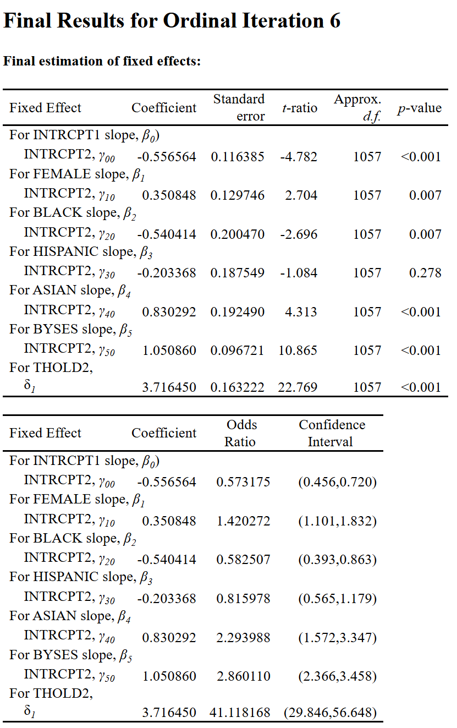
Q1)
Intercept γ₀₀: The average log odds of being in the lowest category, BA graduate, for a white male student with 0 socio-economic status at the base year.
Black slope γ₂₀: the expected difference in the log odds for being in in a higher category, HS graduate, versus a lower one, BA graduate, between black and white students, holding other coefficients constant.
BYSES slope γ₅₀: The expected change in the log odds of being in a higher category, HS graduate, versus a lower one, BA graduate, for each 1-unit change in the socioeconomic status of the base year of the student.
δ₂: The Average log odds that a student will be in the second category or lower, while all the covariates are 0. This represents the distance between the different categories.
Q2)
The log odds of a black student with SES =1 having obtained a college degree:
- The intercept (containing the log odds of BA grad category) + Black slope + BYSES slope = -0.556564 + -0.540414 + 1.050860 = -0.046118
- In probability terms: 48.85%
- Adding the high school degree, which is done by adding the distance δ₂, then the log odds = 3.716450 – (-0.046118) = 3.762568
- In probability terms: 97.73%
- The first calculation accounts for a black student with 1 unit of socio-economic status at the base year, while having a BA degree. On the contrary, the second calculation subtracts the probability (or log odds) of the first theta from the second, in order to account for the same student but in a different category, a high school graduate. Since the log odds in the first category are negative, which means more log odds of achieving lower values for the first category versus the second, the overall log odds increased.
Q3)
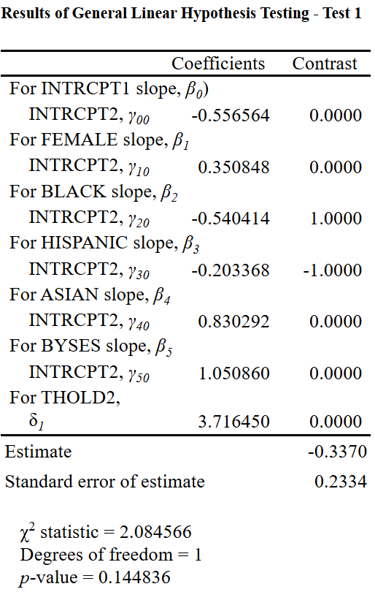
According to our Wald test’s results, we have a large p-value, larger than 0.05, thus we retain the null hypothesis. Moreover, we don’t have enough statistical evidence which suggests that there is no significant differences between the black-white gap and the Hispanic white gap.

H0: β_Black = β_Hispanic
Q4)
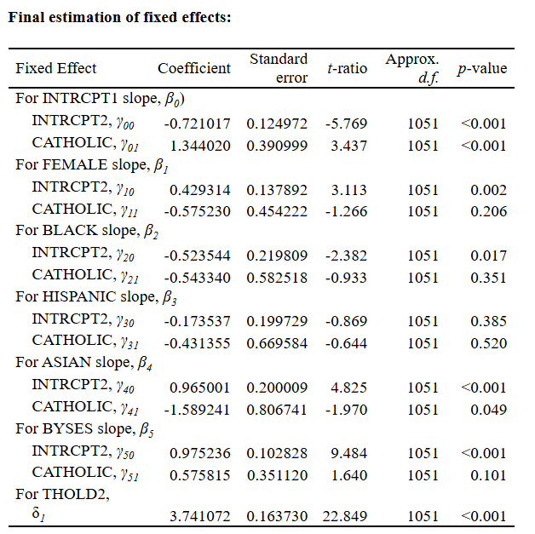
In comparison to the former model, without the effect of the type of school, we see major shifts. First, the intercept, which is the log-odds for a white student to be in the lowest category, the BA graduate, got decreased after accounting for the effect of school. which means now we can see that there is a school gap as the white male student with 0 socioeconomic status at the base year in a public school is -0.721017 (in comparison to the older model -0.556564) which means that his probability in being in a higher category decreased. But in a catholic school, Y01, the log-odds 1.344020, which refers to the same student but in catholic school, means that there is a high log-odds for him in being in a higher category, like High school graduate or less than HS graduate. So overall, catholic school here has a more weakening effect when it comes to educational attainment.
For the gender effect in light of the type of school effect, the Y10, the coefficient for a female in a public school increased, meaning that there is a high log-odds for such student to be in a higher category. Whereas the opposite is true in catholic school for female students. A coefficient, y11, equals to -0.575230 means that there is a less log-odds for such student to be in a high category or in a less educational status. However, the p-value for that coefficient, y11, is large; thus, we conclude that there is no evidence to suggest that there is an effect of the type of school when it comes to gender.
As for black students, the coefficient, which is for a black student attending a public school, did not change much. It is now equal to -0.523544, while it was -0.540414 before adding the effect of the school. The catholic coefficient refers to the expected log-odds for a black student attending catholic school. Since it is in negative, this refers to lower log-odds in being in a high category. Thus, this shows some probable evidence of having better academic attainment in such school. However, the coefficient for the school effect here has a large p-value that suggests that there is no statistical significant association in this regard, thus make the probable evidence void.
As for the rest of the coefficients, we see that some of the main effects changed a bit, some increased and others decreased. However, there is a recurrent theme, which is the large p-values when it comes to the school type effect, except for the marginal p-value for the Asian students attending catholic schools. Overall, we infer that there is no enough evidence to suggest that there is a statistical significant association between the type of school, whether public or catholic, and the effect of gender, socioeconomic status at the base year, black race, and Hispanic race, other than that, there is statistical evidence for an association between the type of school and the educational attainment for white and Asian students.

Compared with the first model, the baseline intercept for public-school students becomes more negative after Catholic school is included. This suggests that school type changes the baseline cumulative logit for the reference group, although the direction still needs to be read in light of the reverse coding of DEGREE.

Part B
Q1)
Note: DEPRIVE coefficient is understood as 1 if there is deprivation, 0 if there is not.
Note: P7READ and DADOCC have been centered around the grand mean.
ATTAIN_{ijk}=θ₀ +γ₀₁*DEPRIVE_{jk} +θ₁*P7READ_{ijk} + γ₁₁*P7READ_{ijk}*DEPRIVE_{jk}+θ₂*DADOCC_{ijk} + γ₂₁*DADOCC_{ijk}*DEPRIVE_{jk} +θ₃*DADUNEMP_{ijk} + γ₃₁*DADUNEMP_{ijk}*DEPRIVE_{jk}+θ₄*MALE_{ijk} + γ₄₁*MALE_{ijk}*DEPRIVE_{jk} + b_{00j} + c_{00k} + e_{ijk}
Θ₀ This is the grand mean achievement or attainment of all female children who have average priori reading achievement (P7READ), average father’s occupation (DADOCC), each with an employed father (assuming that DADUNEMP = 1 if unemployed, = 0 if otherwise), and finally with no neighborhood deprivation.
γ₀₁*DEPRIVE_{jk} The expected difference in the overall attainment between students who suffer neighborhood social deprivation and those who don’t. this refers to the neighborhood effect’s gap.
Θ₁ this coefficient represents the expected change in overall attainment with each 1-unit increase in the level/achievement of the prior reading achievement for the child for who don’t suffer neighborhood social deprivation, holding the rest of the variables constant.
γ₁₁*P7READ_{ijk}*DEPRIVE_{jk} The expected difference in the overall prior reading achievement between students who suffer from neighborhood social deprivation and those who don’t.
Θ₂ This is the expected change in the overall attainment with each 1-unit increase in the occupational prestige of the father for the child for who don’t suffer neighborhood social deprivation., holding all other variables constant.
γ₂₁*DADOCC_{ijk}*DEPRIVE_{jk} The expected difference in the occupational prestige of the fathers of the students between students who suffer from neighborhood social deprivation and those who don’t.
Θ₃ This is the mean difference in attainment between children whose fathers are unemployed and those whose fathers are employed for the children for who don’t suffer neighborhood social deprivation.. this is the father’s employment status’ gap.
γ₃₁*DADUNEMP_{ijk}*DEPRIVE_{jk} The expected difference in the occupational prestige of the fathers of the students between students who suffer from neighborhood social deprivation and those who don’t, holding all variables constant
Θ₄ this is the mean difference in attainment between male and female students, for the child for who don’t suffer neighborhood social deprivation, holding all variables constant.
γ₄₁*MALE_{ijk}*DEPRIVE_{jk} The expected difference between male and female students which is between students who suffer from neighborhood social deprivation and those who don’t, holding all variables constant.
b_{00j} this is the random main effect of neighborhood j, averaged over all schools (rows)
c_{00k} this is the random main effect of school k averaged over all neighborhoods (columns)
e_{ijk} this is the within-cell random effect that represents the deviation of student ijk’s outcome from the predicted outcome based on student’s attainment.
All fixed effects, the neighborhoods effect, are averaged over all schools.
Q2)
Note: P7READ and DADOCC have been centered around the grand mean.
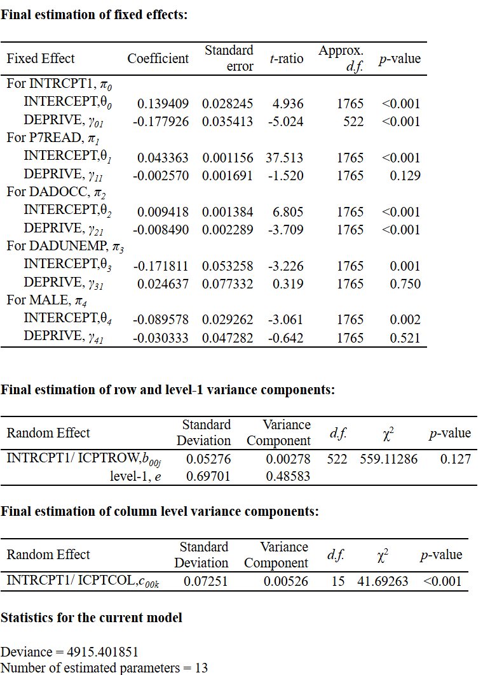
There is statistical evidence that there is association between neighborhood social deprivation and achievement, while controlling for relevant covariates. According to the γ_{01,} the p-value is substantially small, which means we reject the null hypothesis. Thus, we have enough evidence that there is statistically significant association between neighborhood social deprivation and achievement. Moreover, this is case for γ₂₁, which means that there is association between the neighborhood social deprivation and the occupational prestige of the father of the student. However, due to the large p-values, we notice that there is no association between neighborhood social deprivation on one hand, and the prior reading achievement (P7READ), the unemployment status of the fathers (DADUNEMP), and gender (MALE) on the other hand.

DEPRIVE = -0.1779, p < .001
Q3)
Note: P7READ and DADOCC have been centered around the grand mean.
According to the random effect component, b_{00j}, which refers to the effect of neighborhood deprivation varies by school attended, we can see that the large p-value, 0.127, compels us to retain the null hypotheses. In other words, there is no statistically significant evidence that the neighborhood effect varies from school to school.
school-level variance significant only means schools differ in average achievement, not necessarily that deprivation effect changes across schools.
Q4)
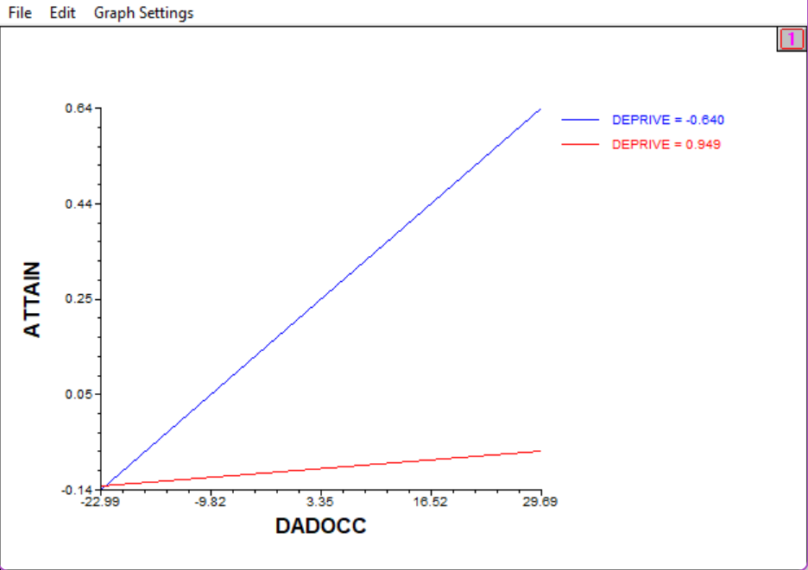
Settings:
X Focus – Level-1 DADOCC – Range of x-axis Entire Range
Z Focus(1) – Level-2 DEPRIVE – Range of z-axis Averaged lower/upper quartiles
According to the value of the statistically significant interaction effect coefficient, γ₂₁, which is equal to -0.008490, and the graph presented above, we can see that the effect of neighborhood social deprivation effect changes the effect of the child-level covariate of the occupational prestige of the fathers, DADOCC. The negative value shows that there is a gap in the level of the occupational prestige of the father between the students who suffer from neighborhood social deprivation and those who don’t. the students who suffer from the deprivation are expected to have fathers with less occupational prestige in comparison to those who do not suffer such issue.

